Final Project Review
Matthew Maciak
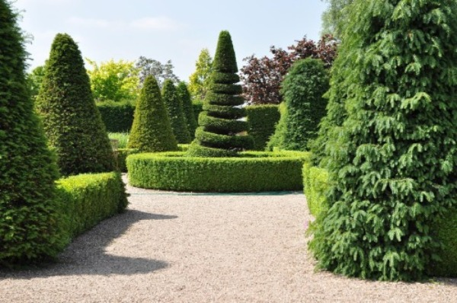
For this assignment I will be using the image above as my reference. One of the main objects in this image is the hollow circle hedge in the center of the image. To recreate this I can use a simple torus. Next across the image in a few places are rows of squared off hedges. This will be easily recreated using one stretched or multiple unaltered boxes. While this can be done either way. Preferably each hedge row would be one box that was stretched into a rectangular prism. Another common object in this image are the rounded tapered hedges. To recreate these a cone shape can be used, or an even better option could be to use a tapered cylinder with a cone on top to more closely match the object in the picture. The most complex object that will require different shapes to recreate is the spiraled hedge in the center of the image. This will require multiple connected torus shapes. With a tapered cylinder and cone on top to complete the 3D recreation. To simplify this recreation first all of the background trees would need to be removed. Also the tapered hedges could be recreated with just a cone shape instead of a tapered cylinder and cone on top.

